Ideation Phase
Define the Problem Statements

Date | 19 February 2026
Team ID | LTVIP2026TMIDS77295
Project Name | Smart Sorting: Transfer Learning for Identifying Rotten Fruits and Vegetables

Customer Problem Statement Template:

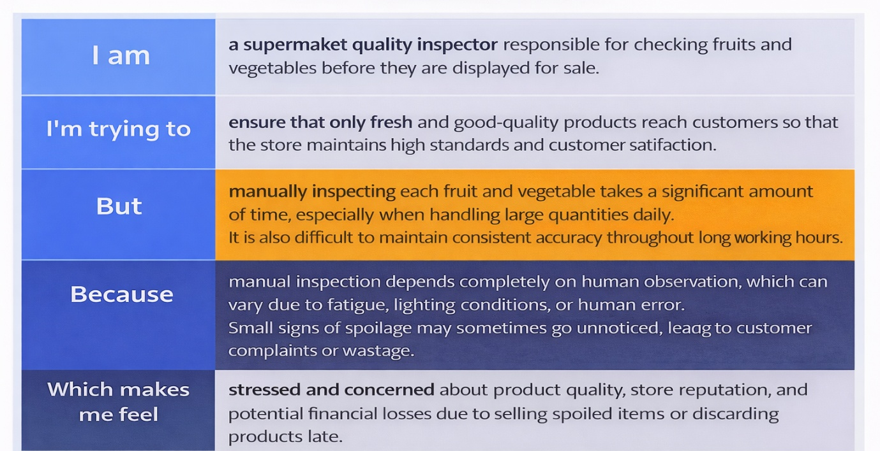

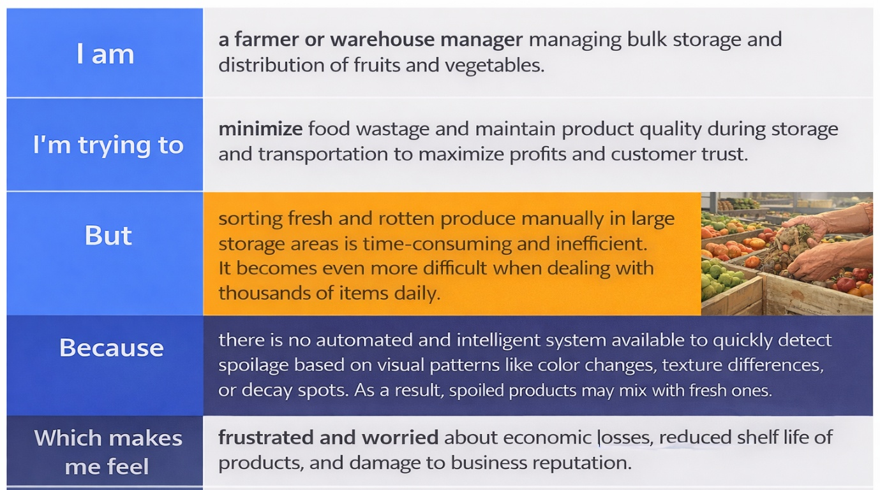
Example:
Problem Statement (PS) | I am (Customer) | I’m trying to | But | Because | Which makes me feel
PS-1 | I am a supermarket quality inspector responsible for checking fruits and vegetables before they are displayed for sale. | I’m trying to ensure that only fresh and good-quality products reach customers so that the store maintains high standards and customer satisfaction. | But manually inspecting each fruit and vegetable takes a significant amount of time, especially when handling large quantities daily. It is also difficult to maintain consistent accuracy throughout long working hours. | Because manual inspection depends completely on human observation, which can vary due to fatigue, lighting conditions, or human error. Small signs of spoilage may sometimes go unnoticed, leading to customer complaints or wastage. | Which makes me feel stressed and concerned about product quality, store reputation, and potential financial losses due to selling spoiled items or discarding products late.

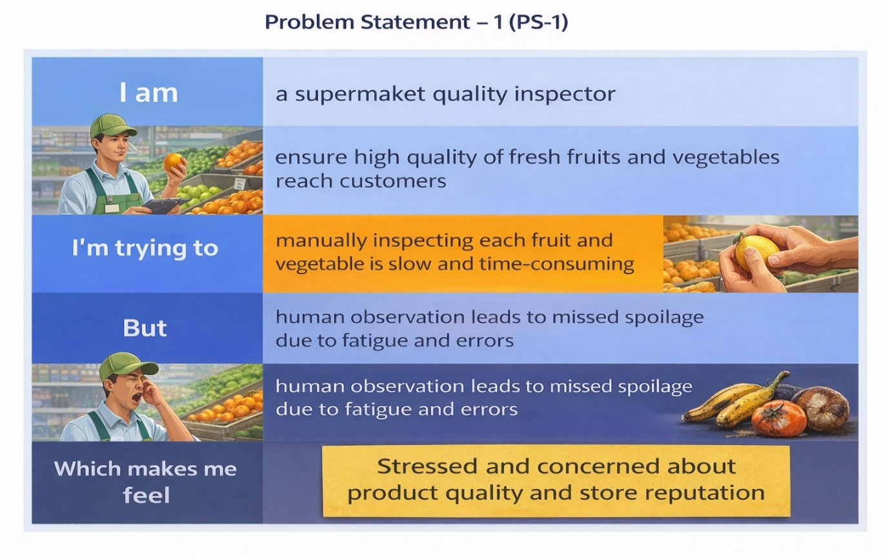

Example:

Problem Statement (PS) | I am (Customer) | I’m trying to | But | Because | Which makes me feel
PS-2 | I am a farmer or warehouse manager managing bulk storage and distribution of fruits and vegetables. | I’m trying to minimize food wastage and maintain product quality during storage and transportation to maximize profits and customer trust. | But sorting fresh and rotten produce manually in large storage areas is time-consuming and inefficient. It becomes even more difficult when dealing with thousands of items daily. | Because there is no automated and intelligent system available to quickly detect spoilage based on visual patterns like color changes, texture differences, or decay spots. As a result, spoiled products may mix with fresh ones. | Which makes me feel frustrated and worried about economic losses, reduced shelf life of products, and damage to business reputation.

